|  |  |
| --- | --- |
|  |  |
|  |  |
|  |  |
|  |  |

# Table of Contents

|  |  |  |
| --- | --- | --- |
| **S.No.** | **Content** | **Slide No.** |
| 1 | Objectives | 2 |
| 2 | Abstract | 3 |
| 3 | Introduction | 4 |
| 4 | Literature Survey | 5 |
| 5 | Problem Identification | 10 |
| 6 | Block Diagram | 11 |
| 7 | References | 12 |
|  |  |  |

* To develop an application which will act as a helping hand for the patient who was in need of the plasma.
* The main objective of the proposed solution is to create database to store the donor details and to notify them upon receiving request from the patient.
* To develop an application which having great responsive user interaction.
  + During the COVID 19 crisis, the requirement of plasma became a high priority and the donor count has become low.
  + In regard to the problem faced, an application is to be built which would take the donor details, store them and inform them upon a request.
* Plasma is the liquid component of blood Plasma is necessary to help your body recover from injury, distribute nutrients, remove waste and prevent infection.
* On covid situation, plasma plays major role on the treatment.
* Via this plasma Donor Application ,donor will receive

an notification upon receiving request from the receptor..

|  |  |  |  |
| --- | --- | --- | --- |
| **TITLE** | **AUTHOR**  **& YEAR** | **JOURNAL NAME** | **REMARKS** |
| Blood donation smartphone app | Afaf AliBatis, Ahmed Albarrak  &  2021 | Science Direct | The top rated features were the ability to request for blood donors, and the ability to locate the nearest blood center on the map.The preferred method of contact was found to be SMS. |
|  |  | International Research Journal of Engineering and Technology (IRJET) | In this system, there are three |
|  | Netra | entities,admin,Volunteer,andusers. |
|  | Shigwan, | Users can post Available medicine |
| Android application for Medicine donation | Pratiksha Chaudhari, Shweta Pawar, Anuja  Gote | with the medicine name, medicine description ,QRcode, and medicine expired date. WhenAdmin assign him medicines, he can open the  user’s address location on the |
|  | & | Google map and go to thatlocation |
|  | 2020 | and bring the medicines. 6 |

|  |  |  |  |
| --- | --- | --- | --- |
| **TITLE** | **AUTHOR**  **&**  **YEAR** | **JOURNAL**  **NAME** | **REMARKS** |
| Mobile phone based system to promote eye donation | WarapornChumkas ian, RitinFernand, Khin ThanWin,  HeidiLord &  2021 | Science Direct | Eye Donor Form generates form using any smartphone .The donation form input is saved electronically and can be forwarded to your family members, healthcare. |
| Instant plasma donor recipient connector web application | Kalpana Devi Guntoju, Tejsvini Jalli, Sreejauppla &  2022 | International Research Journal Of Modernization in engineering Technology and Science | In this proposed system, a donor who wants to donate plasma and can donate the plasma to a blood bank. The blood bank after checking the donor certificate can make a request to the donor. |

|  |  |  |  |
| --- | --- | --- | --- |
| **TITLE** | **AUTHOR**  **& YEAR** | **JOURNAL NAME** | **REMARKS** |
| BLOODR : blood donor and requester mobile application | Vamsi krishna tatikonda, hosam el-ocla &  2021 | mHealth | BLOODR application creates communication channel through authenticated clinics whenever a patient needs blood donation. It is a useful tool to find compatible blood donors who can receive blood request posts in their local area. |
| Blood donation and life saver- blood donation app | M.R. Anish Hamlin, J.  Albert Mayan& 2020 | IEEE | At the emergency time of blood needed we can check for blood donor nearby by using GPS. Once the app user enter the blood group which he/she needed it will automatically show the donor nearby and send an alert message to the donor. |

|  |  |  |  |
| --- | --- | --- | --- |
| **TITLE** | **AUTHOR**  **& YEAR** | **JOURNAL NAME** | **REMARKS** |
|  |  |  | This app fits the general realm of AI |
| Food donation app for smart living | Christina Varghese, Drashti Pathak  &  2021 | IEEE | for Smart Living in Smart Cities. In addition to entailing IoT and ubiquitous computing, this work makes positive impacts on both healthcare and environment by reducing hunger and food waste respectively |
|  | Arushi Singh, Shilpi Sharma &  2020 |  | Mobile application to connect |
|  |  | people who are interested in |
|  |  | donating their books to those who |
| Application for book donation | IEEE | might be in need.It will connect the needy and the donors and enable  them to get the books that they |
|  |  | require from people that are done |
|  |  | using them. 9 |

|  |  |  |  |
| --- | --- | --- | --- |
| **TITLE** | **AUTHOR**  **& YEAR** | **JOURNAL NAME** | **REMARKS** |
| Mobile application for donation of items | Shubham Belekar , Rahul Rajput , Karan Gharat &  2021 | VIVA-Tech International Journal for Research and Innovation | The proposed application shall reduce food wastage and also fulfil other requirements like clothes, etc. of needy organizations. |
| Blood Donation Management System | Devanjan K. Srivastava, Utkarsh Tanwar  & 2021 | International Journal of Creative Research Thoughts | This system is very User-friendly and interactive between the donor and the recipient. Our system allows the donor to know the emergency by sending a web notification to the recipient. |

* + As we all know that getting infected by virus, there’s requires more amount of defense nutrients in our body.
  + To handle the situation, having good plasma on our circulatory systems make it more defendable against it.
  + To get the plasma at the right time was difficult.
  + For that having a dedicated application to get plasma at a right time saves lot of time and lives.

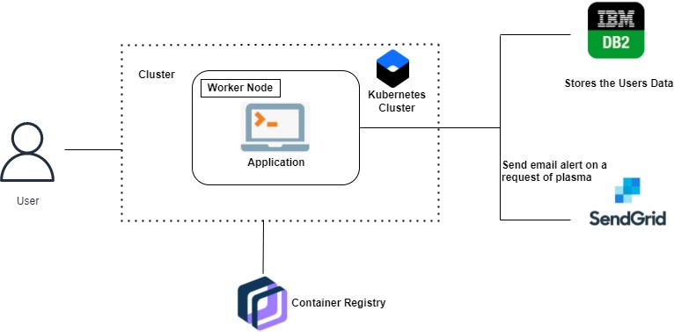

1. Kavita shirsat, Iqra shaikh,Pradnya Deshmukh,Mayuri lambhate4,Food donation application: food share, International research journal of engineering and technology (IRJET), volume: 08 issue: 05 | May 2021
2. Shubham Singh Rana, Satvik Maheswari, Shiv kumar, Ms. Jyoti thakur,Charity-based application, Journal of xi'an university of architecture & technology, Volume XII, issue IV, 2020
3. Sofhioubhi,Jose Luis Ferandez-Aleman,Ambrosio toval,ali idri,Free blood donation mobile applications,Journal of medical systems,May 2015.
4. S Periyanayagi,A Manikandan,M Muthukrishnan ,BDoor App- Blood Donation Application, Journal of Physics: Conference Series,2018.
5. A. Meiappane,K. Logavignesh,R. Prasanna,T.Sakthivel,Blood Donation App Using Android, IEEE International Conference on System, Computation, Automation and Networking (ICSCAN), 29-30 March 2019
6. Altahir Saad ,Ahmed Saad,Lars Rune Christensen, Blood Donation & Blood Banks through Android Mobile App and Web Application System , International Journal of Computer Science Trends and Technology (IJCST) ,Mar - Apr 2019
7. Nikita M. Lunawat, Chetan D. Kshirsagar , Ashish A. Gawhande , Rohini M. Rathod,Blood and organ for patient using andriod application, International Journal of Research in Engineering and Technology,May-2016.
8. Blood App, American Red Cross, 2016. Available online: